Er RAJAT KALIA
(B.TECH IIT-Delhi)
PH. 9815439805
Er MANISH KALIA
B.TECH (Delhi COLLEGE OF ENGINEERING)
PH. 09990074601,9878146388

9DE

Dispute in 1654 led to the creation of a mathematical theory of prabability by two famous french mathematicians Blaise Pascal and Pierrede Fermet . First fundamental principles of prabobility theory were formulated for Ist time In popular dice game. Consisted in throwing a pair of dice 24 time, the problem was to decide whether or not to bet even money on occurrence of at least one "double six" during 24 throws. By gambling rule chevalier de mere believed it would be profitable but c caluclation shows just opposite .
Dutch scientist christion Huygens in 1657 published the first book of probability entitled De Ratiociniis in Ludo Aleac.
In 1812 pierse de laplace introduced a host of new ideas and mathematical techniques in his p book .
Equally likely - If two events are called equally likely if none of the events have preference of occurence of other .
Nutually exclusive :- If occurence of one event rules out lthe ocurrence of other .
Exhaustive :- Set of event in experiment is said to exhaustive it nothing happen than those listed possible out comes can occur as a consequence of the experiment .
Total out comes of experiment is called sample space .
A; 'm' out comes favour the occurence of event A .
P (A) = 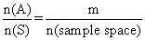
P() = complement of A P (A^{c})
P ()= 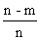= 1 - P (A)
P(A) + P() = 1
0 P (A) 1 sure ivent
Impossible event img sure event
Example of kequally likely events :-
When a unbiased coin is tossed then occrenice of head or tail are equally likely .
Example of mutually exclusive event -
Let sample space of unbised die is die is S = {1, 2, 3, 4, 5, 6} in which E₁ = {1, 2, 3,} = ecent of occurrence lof no. less than 4 & E₂ = {5, 6} = event of occurrence of no. greater than 4.
cleaarly . E₁ E₂ =
so, E₁ and E₂ are mutually exclusive .
Examples of exhaustiv event :-
Let sample space of unbiased die is S = {1, 2, 3, 4,5, 6} in which E₁ = { 1, 2, 3, 4} = Event of occurence of no . less tahn 5.
& E₂ = {3, 4, 5, 6} = Event of occurence of no. Greater than 2.
Then E₁U E₂ = {1, 2, 3, 4, 5, 6} = 5
Hence E₁ & E₂ are exhaustive events .
Odds in favour :- If 'a' is no of cases favourable to odds in favour of E are a : b & odds against of E are b : a.
P (E) = 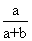
& P (E¹) =
P(E) + P(E¹) = 1
Illustration :- A person while dialing 7 digit phone no. forget last two digit and he randonly dials 2 numbers .
Find the chance of currect no.
Ans - There are 10 digit on phone.
1st digit can be dialled in 10 ways.
2^{n} digit can be dialled in 10 way .
sample space (total no. of ways two digit can be dialled)
= 10 X 10 = 100
But there is only 1 currect no.
So, P (A) = 1/100
Independent and dependedt event :- Two event are said to be independent if occurence or non - occurence of are does affects the probabitity of occurence or non-occurence of the other .
eg. Occurence of head or tail is independent on each other.
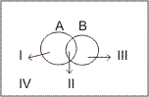

Venn diagram :-
I A (A but not B )
II A B
III B ( B but not A
IV
P(A or B) = P(at least one of A or B)
P(A img B) = P(A) + P(B) - P(A img B)
= I + II +III
= (I + II) + (III + II) - II
P(A B) = P(A) + P(B) - P (A B)
P (A B) = P ( A ) + ( B ) + P (A B )
= P(A) + P( B)
=| - P ( )
P (exactly one A or B) = I + III = P ()
=P(A) + P(B) - 2P (A B)
= P(A B ) - 2P(a B)
Note :- For mutually exclusive event
P(A B) = 0
For exhaustive event
(A img B) = Sample space
Conditional probability :-
Probability of ocurence of an event B when it is known that some event A has already occured .It is P(B/A)
P(B/A) = 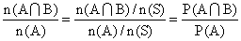
P(B/A) = 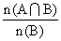, 0 P(B) 1
P(B A) =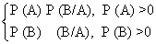
P(B/A) = P(A )
Note - For independent events -
P(A B) = P(A). P(B)
Dumb Question :- How P(A B) = P(A) P(A/B)
Ans - P(A/B) = probabilituy of ocurence of A in B
ie, simultanous occurence
Probability of simultaneous occurence of A and B
P(A/B) = Probability of B
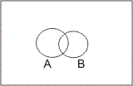
P(A/B) = 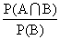
Illustration - If 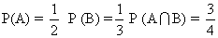
Find
Ans -
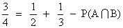
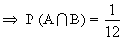
P(A/B) = 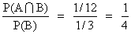
= 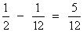
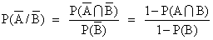
=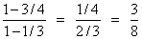
P(A / B) + = 1 = 1
= 1 - P(A / B)
= 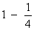
=
Bernoulli strial :- An experiment 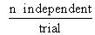out come
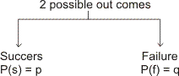
p + q = 1
P(getting r' s success) = n C_{r} p^{r} q^{n-r}
P 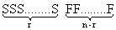
= p^{r} q^{n-r} nC_{r} img arrangement in a row
P (getting r + 1 success) = nC_{r+1} q^{n-r-1}p ^{r+1}

Bagrang's relation ship
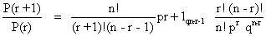
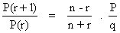
Dumb Question :- How relation P (getting r' s success)
= P^{r} q^{n-r} nC _{r}
Ans - In this P is probability of getting success and q is probability of getting failure and p + q = 1
Sclection of r success out of n out comes = nC_{r}
img..... P(getting r' s success)
= P x P x P...............r times x q x q x.............(n - r) times x nC_{r}
Illustration :- A die is rolled n times. Find the value of n if probability of getting at least one ace is 91/216
Ans P(getting at least one ace) = 1 - P(no ace)
P(1) = 1/6 P(not 1) = 5/6
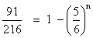
=> n = 3
Probability theorem - (Baye's theorem)
If an event A can occur with n mutually exclusive, exhaustive
event B₁, B₂, ..............B_{n} and probability of P(A/B₁),
P(A/B₂), ................P(A/B_{n}) is known. Then probability .
P(Bi/A) = 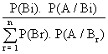
P(A img B_{i}) = P(Bi). P(A/Bi)
= P (A). P(Bi/A)
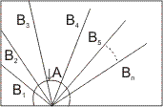
P(A) = P(A img B₁) + P(A img B₂) + ......+ P(B_{n}) P(A/B_{n})
= P(B_{i}) P(A / B_{i})
=P(A). P(B_{i} / A)
P(A) =
=P(B₁) P(A / B₁) P (A / B₂) + ............+ P(B_{n}) P(A / B_{n})
P(B_{r}) P (A / B_{r})
Illustration :- A bag cintains 5 balls of unknown color. Two balls are drqwn and both are found to be white. Find the chance that there are 4 white ball in box . Assume any no. of white ball equally likely .
Ans - A : Two balls drawn from a bag contuins 5 balls.
both are white
B₀ : 0 white ball
B₁ : 1 white ball
B₂ : 2 white ball
B₃ : 3 white ball
B₄ : 4 white ball
B₅ : 5 white ball
P(B₀) = P(B₀) = P(B₁) = P(B₃) = P(B₄) =P(B₅) =P(B₆) = 1/6
P(A/B₀) = 0 P(A/B₁) = 0
P(A/B₂) = 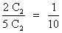
P(A/B₃) = 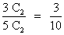
P(A/B₄) = 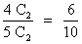
P(A/B₅) = 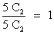
P(B₄/A) =
=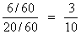

Dumb question - Why probability of P(A/B₀) and P(A/B₁) is zero ?
Ans - Because in event we are getting 2 white ball.
and when in sample we have none or one white we can not get 2 white ball.
Stockist approach :-
Q- A bag contains 5 fair coin, 2 doulaly headed coin, 2 doubly tailed and are biased coin. Probability of head with biased = 2/3 . A coin is selected and tossed. If head appeared same coin is tossed and if tail appears another coin selected from remaining and tosed. Find the chasce -
(1) Same .coin is tessed twice .
(2) Chance .head appears in both toss.
(3)If head appears in both wins. find the chance that it is doubly headed coin .
Ans - Total coin = 5 + 2 + 2 + 1 = 10
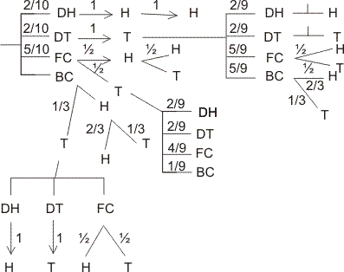
(1) P(getting H in I ^{st} toss) =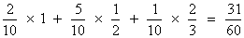
(2) P(getting both (H H) in 2 toss) = 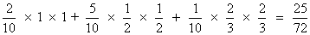
(3) P(Doubly head / H H ) 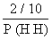
=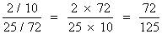
In finite samble space (Geometrical probaility ) :-
(1) If a point is randomly sclected from area 'S' which indudes an area 6 then chance that it is sclected from area 6
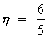
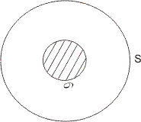
(2) If a point is randomly taken from line AB of length L then chance that it is selected from the segment PQ(l) contained by AB is = l/2
Illustration :- In a circle of radius 'a'. Find the probalility that point is close to the circumference than to its centre.
Ans - n(S) =
E : Point is close to circumference than oits centre.
P(E) = 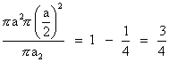
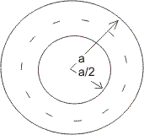
Dumb question - How probability of " point is close to circumference than its centre " is 3/4 .
Ans - A point is close to circumference than its centre when it lies in region of outside the circle of r = a/2 and inside the circle of r = a .
P(E) = 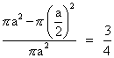
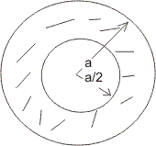
Easy level
Q. 1 - A natural no. is randomly selected. Find the chance that digit in unit place of its square is 4.
Ans :-
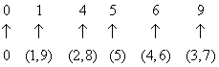
There are only two digit (2 and 8). Whose square's unit place is 4.
So, P(E) = 2/10 = 1/5
Q. 2 4 red and 3 white ball are arranged | n a row. Find chance that two ball at extreme are whit .
Ans :- Case I:- alike balls
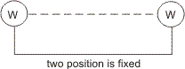
n(S)=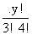
n(A)= 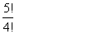
P(A)= 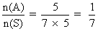
Case2:- Different balls-
n(S) = 7!
n(A) = 3C₂. 2!, 5!
P(A) = 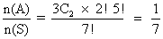
Q. 3- P(A) = 1/2 ,P(B) = 1/2 . Find the least and greatest valume of intersection P(A img B).
Ans - P(A B) = P(A). P(B/A)
P(A B) greatest = 1/2 if P(B/A) = 1
= 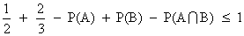
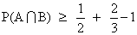
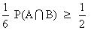
Q. 4- A and B are independent then show that and are also independent .
Ans - Note - If and are independent. then P(A) . P(B)
T.PT :-
L. H. S. :- { 1 - P(A) } { 1 - P(B)}
= 1 - P(A) - P(B) + P(A) . P(B)
= 1 - [P(A) + P(B) - P(A B)]
= 1 - P(A B)
= P ()
Q. 5 - Two cords are drawn from 52 cards pack. Find the chance that both the cards are aces.
Ans- n(S) = no. of ways drawing 2 cards from 52 cards.
= 52 C₂
n(A) = no. of ways drawing 2 ace cards from 4 ace card
= 4 C₂
P(E) = 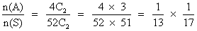
P(E) =

Q. 6- In a bag 4 cards morked with 'I' and. 4 marked with 'T' are present . 3 time a card is drawn without .
replacement. Find the chance of forming wird 'I I T'.
Ans - Total no. of way
= n(S) = 8C₃
drawing 3 cards
n(A) = 4C₂ X 4C₁
P(E)= 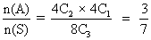
Dumb question :-
How does n(A) = 4C₂ X 4C₁ ?
Ans:- For wird 'I I T' we reguire 2I'_{s} and I 'T' So, out of 4 I' s we require 2 I' _{s} and out of 4 T'_{s} ,we require 1 T. So, n(A) = 4C₁
Q. 7 - Probability of a no. appearing if a clice is rolled is proportipnal lto the ,no. Find the chance of getting aprime no ?
Ans- Probability . P(1) = P(2) = 2
P(3) = 3 P(4) = 4 P(5) = 5
P(6) = 6
P(1) probability of getting 1 if clice is ralled
P(1) + P(2) + P(3) + P(4) + P(5) + P(6) =
= 21
But 21 = 1 total prabability
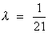
P(prime) = P(2) + P(3) + P(5) = 10 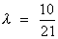
Q. 8 - A Coin is tossed l4 time if head appeared 1 point awarded and tail appeared 2 point given. Find expectation of player ?
Ans- P(4) = P(HHHH) =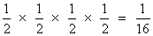
P(5) = P ( HHHT/HHTH/HTHH/THHH )
= 4 X 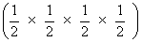
=
P(6) = P (HHTT/HTHT/HTTH/TTHH/THTH/THHT)
= 6 X ( 1/2 X 1/2 X 1/2 X 1/2 X )
= 6/16
P(7) = P(HTTT/THTT/TTHT/TTTH )
= 4 x 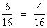
P(8) = P(TTTT) =
P(4) probability of getting 4 points.
Expectation = 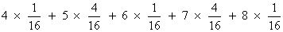
= [ 4 + 20 + 36 + 28 + 8 ]
= 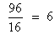
Dumb question :- What is expectati0n ?
Ans - If P be probability of success of a person in any event and M be prize money which be will receive in case of sussess, themn,
Expectation = PM = probability of success X prize money
Q. 9- There are 3 compartment in a box. A ball is randomly drawn from anyone compartment. Find chance it is ded
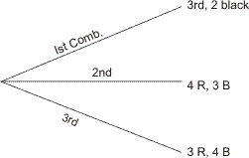
Ans - E₁ frawn from I_{st} compartment
E₂ frawn from II_{nd} compartment
E₃ frawn from III_{rd} compartment
E . bll is red
P( E₁ ) = P( E₃ ) = 1/3 ( equally likely event )
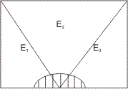
P(E) = P( E img E₁) + P( E img E₂) + P( E img E₃)
= P( E₁ ) P( E / E₁ ) + P( E / E₂ ) + P( E / E₂ ) + P( E/E₃ ). P( E / E₃ ) = 3 / 7
P(E) = 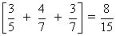
Q. 10 A coin is tossed till head and tail appears, it can be tossed 5 time max . First 2 throws are H H . Find the chance that coin tossed 5 time.?
Ans- Ist two throws are H H and if 3 ^{rd} and 4th throw are also H H . So we have to go for 5th throw for getting tail.
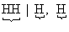
P(A) = 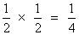

Medium level
Q. 1- A, B and C are three event such that -
P(exatly one A or B) = P(exactly one B C)
=> P(exactly one C or A) = P
and = p² and A, B and C are
exhaustive. Find = value of P .
Ans - Not :- In exhaustive events
= 1
P = P (a) + P (B) - 2P ( A B )
P = P (B) + P (C) - 2P ( B C )
P = P (C) + P (A) - 2P ( C A )
3 P = 2 (P(A) + P(B) + P(C)) - 2P(A B) + P(A B) + P(C A))
P(A) + P(B) + P(C)[ ( A B) + P(B C) +P(C A) ]
+ [ P(A B) + P(B C) +P(C A) ] P(A) + P(B) + P(C) ...........(1)
P(A B C) = P(A) + P(B) + P(C) - [ P(A B) + P(B C) + P(C A) + P(A B C)........(2)
+ P (ABC) = P(ABC)
If A, B and C are exhaustive .
then P(A BC)=P(A) + P(B) + P(C) holds -
From eqn ........... (2)
P(A B C) = P(A B) + P(B C) + P(C A)
P utting in eqn ............ (1)
+ P(ABC) = P(ABC)
+ P² = 1 ..............(3)
On solving
P =
Q. 2. 12 face cards are removed from 52 cards and remaining 40 cards are well shuffled and 4 cards are drawn from pack of 40 cards. Find the chance that all four are of different suit and different denomination .
Ans- Heart Diamond club spade
n(s) = 40 C₄
No. of way drawing Ist card = 40 ways
No. of way drawing 2nd card = 27 ways
No. of way drawing 3rd card = 16 ways
No. of way drawing 4th card = 7 ways
Total no. of way of drawing all 4 cards = 40 X 27 X 16 X 7
Dumb question - Why NO. of ways of drawing 2nd card is 27 ?
Ans- Let Ist card drawn is ace of Heart. So, no, Heart and no ace card is further selected. So remaining cards are (40 - 10 - 3) = 27
So, 27 ways
P(E)= i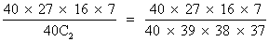
Q. 3 - There are two luts of article one lot contains 3 defective and 5 good article and other lot contains 4 defective and 8 good articles. A lot is randomly seleste a and 3 articles are drawn . this lot will be rejected if 2 or mor than 2 article are found to be defective. Find the chance that this be rejected.
And - E₁ Ist lot is chosen
E₂ 2nd lot is chosen
E lot is rejected
P(E) = P(E¹) P(E/E₁) + P(E₂). P(E/E₂)
P(E₁) = P(E₂) = 1/2 (equally likely events)
P(E) 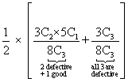+ 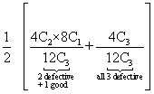
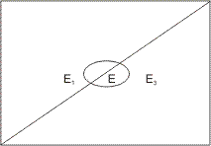
Q. 4 A boy contains | coin of worth M rupees and n coins of total . Worth of M rupees. Coins are drawn without replace -ment till coin whose valime is M, is drawn, I Find the expectaion of draw .
Ans - P(drawing M in Ist draw) = 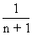
P(drawing M in 2nd) drawn) = 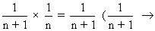other coin draw, 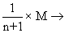drawing of M)
P(drawing M in (r + 1)^{th} draw) =
Expectation = M coin draw In Istdraw, + 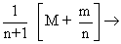Mcoin draw in IInd draw , + 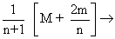In 3rd draw
= 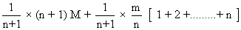
= 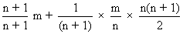
Expectation = 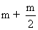
Q. 5 - A letter is known to khave either from Agra or from Mathura or. Satara. on the stamp two consecultive word 'RA'are legible. Find the chance that letter from Agra .
Ans- A : .Two consecutive word 'RA'are legible .
B₁: . letter is from
B₂: . letter is from
B₃: . letter is from
P(B₁) = P(B₂) = P(B₃) =
P(B/B₁) = 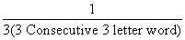=
P(A/B₂) = 1/6. P(A/B₂) = 1/5.
P(A) = P(B₁). P(A/B₁) + P(B₂)+ P(A/B₂) + P(B₃) P(A/B₃)
= 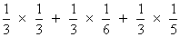
P (B₁ / A) = 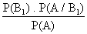
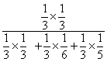
P(B ₁ / A) =

Dumb question - Q. How . P(A/B₁) = ?
And - B₁ Letter from AGRA
So, in AGRA there are 3 two letter consecutive word AG, Ga, RA
and A RA is legible
So, there is only one 'RA'
P(A / B₁) =
Hard level
Q. 1 Aline of length L is divided (broken ) in to there parts randomly . Find the chance that these parts are the possible sides of
Ans- For to be sides of ,
x > o, y > o
L > X + y
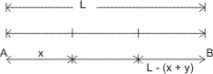
Sum of two sides .> third side
x + y > L -(x + y)
(x + y) > .........................(1)
L - x > X
=> ...................(2)
L - y > y
..................(3)
n(s) x L x L =
(from eqn. L > x + y)
n(A) = Area of ABC
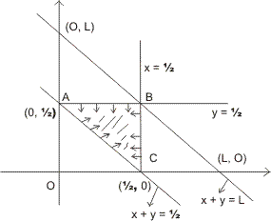
x x
= x
P( E )= 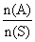
= 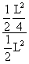=
Q. 2 A box contains 6 balls. It is equally likcly that ball is white or black . Two balls are drawn from this bag one is foond black and one is whit.
find the chance that there is 3 black ball in the box .
Ans . 1st ball can be white of black = 2 way
2nd ball can be white of black = 2 way
img ............Total no. of ways in which 6 balls can be white of black
= 2 X 2 X 2 X 2 X 2 X 2 = 2⁶ ways
n(s) = 2⁶
P(B _{o}) = , P(B₁) = 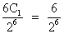
P(B ₂) = 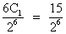, P(B ₃) 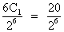
P(B₄) 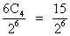, P(B ₅) 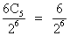
P(B ₆) = 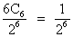
A Two balls drawn from bag & of diff. color
P(A / B₀) = o [b/c in draw of 2 balls one black ball is there]
P(A / B₁) = 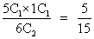
P(A / B₂) = 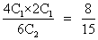
P(A / B₃) = 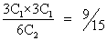
P(A / B₄) =
P(A / B ₅) =
P(A / B₆) = 0
P(A) = P(B_{o}) P(A / B_{o}) + P(B₁) P(A / B₁) + P(B₂) P(A / B₂) + P(B₃) P(A / B₃) + P(B₄) P(A / B₄) + P(B₅) P(A / B₅) + P(B₆) P(A / B₆)
= 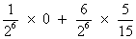+ 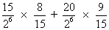
+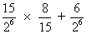 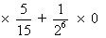
P(B₃/ A) = 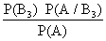
= 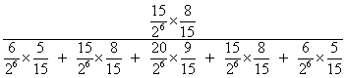
= 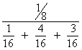
P(B₃ / A) = 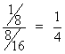
Q. 3- Three whole no. is selected at random and multipliea find the chance that-
(1) Their product is divisible by 5 but not 10.
(2)Divisible by 10 .
(3) is an even no.
Ans- E₁ Digits at unit plce of 3 whole no. 1, 3, 7, 9
E₂ digits at unit place of whole no. is 1, 3, 5, 7, 9
E₃ digits at unit place of 3 whole no;s is 1, 2, 3, 4, 5, 6, 7, 8, 9 there are 10 digits -
P(E₁) = 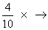Ist Whole no. , 2nd Whole no., 3rd Whole no., = 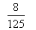
P(E₂) = 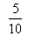=
P(E₃) = =
divisible by 5 not by 10 at unit place only 5 is there .
(1) P(divisible by 5 not by 10 ) = P(E₂) - P(E₁)
= - = 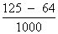
= 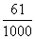
(2) (divisible by 10 means last digit is zers )
= 1 - - = 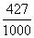
Dumb question -
Q. How P(disivible by 5 not by 10 ) = P(E₂) - P(E₁)
Ans- Divisible by 5 not 10 only when at uniy place only 5 is there.
P(E₁) = Prob. of having 1, 3, 7, 9 at unit place
P(E₂) = Prob. of having '5' at unit place
= P(E₂) - P(E₁)
=P (divisible by 5 not by 10)
(3) P(even) = 1 - P(E₂) [ have digit 2, 4, 6, 8 at unit place ]
= 1 -
=

Key words
• Sample space
• Equally likely events
• Mutually exclusive events
• Exhaustive events
• Independent events
• Expectation value
• Bernoulli's trial
• Boye's theorem (Total frobability theorem)
• Infinite sample space

